**Name: Mudit Mohit**

**Enrolment No.: BT21GCS057**

**Section: B2**

**Looping and jumping**

CLR A  
MOV R2,#10  
AGAIN: ADD A,#01H  
DJNZ R2,AGAIN  
MOV R5,A

END

Ans. 0000| CLR A

0001| MOV R2,#21

0003| AGAIN: ADD A,#42H

0005| DJNZ R2, AGAIN

0007| MOV R5, A

END

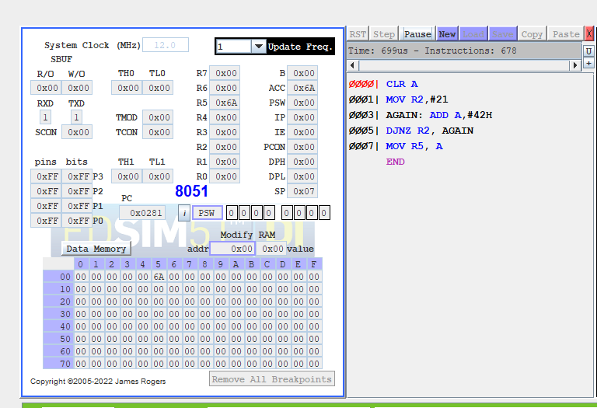

**Array example. The base address is 20H. The array size is 10. 01H needs to be stored in all the array locations.**

mov R1,#20H

mov R2,#10

AGAIN:

mov @R1,#01H

inc R1

DJNZ R2,AGAIN

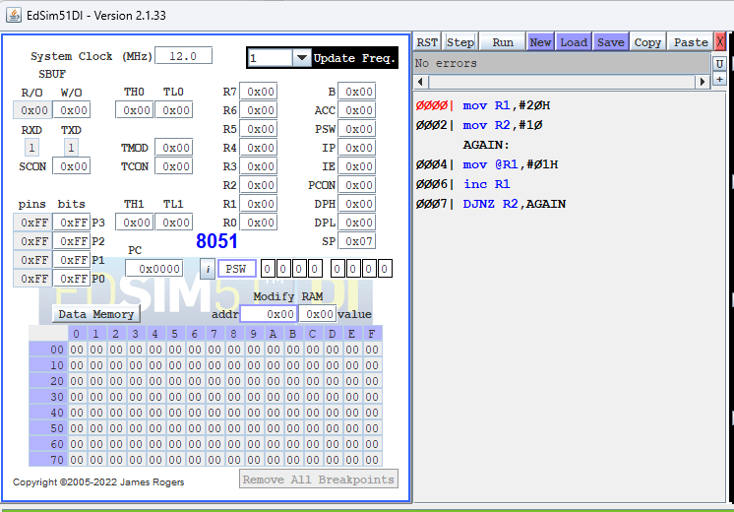

**Q Write a program to add the elements stored in an array.**

**Ans.**

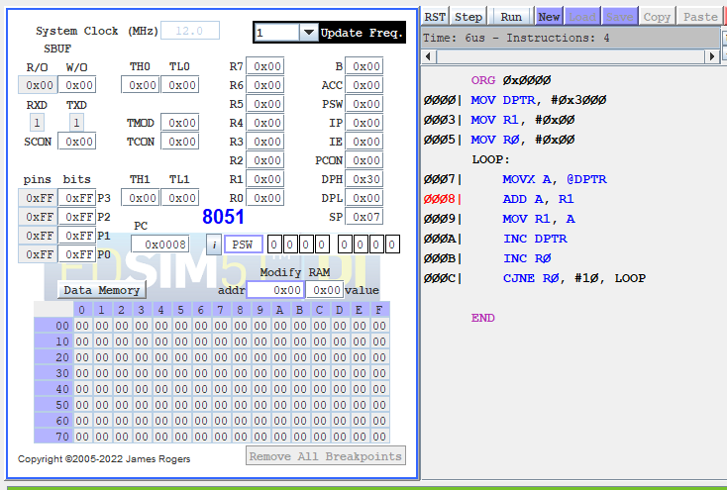

**Q CJNE is used to compare two numbers and jump. Study CJNE and write a program to demonstrate the use of CJNE.**

**Ans.**

